MY FIRST DAY IN PRESERVER TEACHING

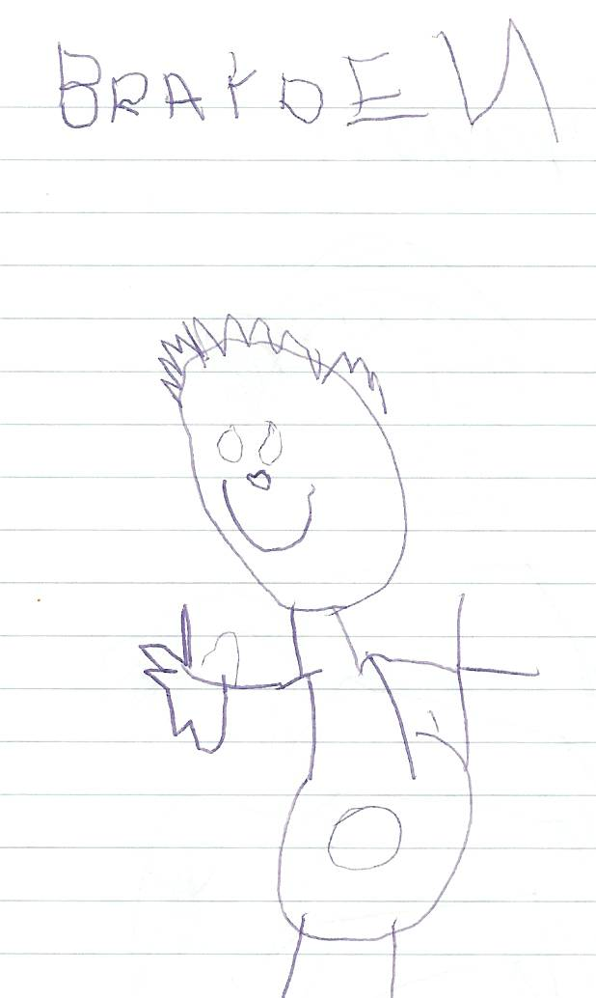
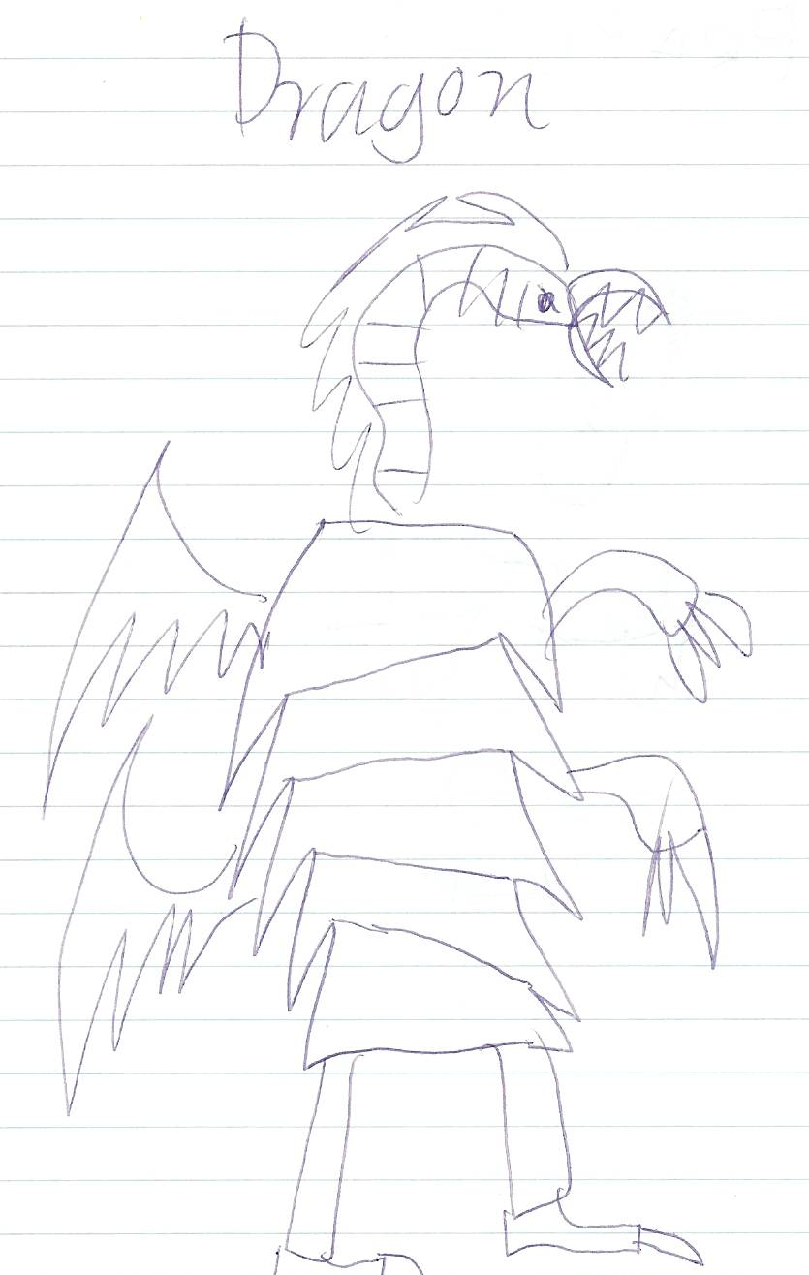

These are pictures I had two of the boys do when they started to become disruptive at the museum book launch, while they were supposed to be quiet on the mat as the presenters were speaking. The school has main stream education, Steiner and Reggio Amelia, parents have the choice of any of these.

I am at Collingwood College, a Prep to 12 School which also has an international school section as well. This class operates under a Reggio Amelia teaching philosophy, which is all about kids becoming their natural best, through their own abilities and questioning.

I am in a class with another VU student called Sara, the class is grade Prep to Grade three and in total there are 55 kids, up from 30 last year. The class room is the area of four class rooms in one, with different sections in it’s open plan design. Today we hung around a little lost and were then directed to our class who were going on an excursion to the Melbourne Museum.

We walked up to the Museum, there were approximately one adult to five children and the kids were rather well behaved. The museum was great and the kids loved it, but among the many other school groups at the museum they were the most uncontrollable. We went to a book launch while we were at the museum, the book was called CHILD’S PLAY AND THE FOLKLORE OF AUSTRALIAN CHIDRLEN by Dorothy Howel, the book was all about how children’s play and games are a language and an important piece of our cultural history and it’s importance also on child development. The kids were really good, but they did get a little restless, they really hung all over the teachers as well. One of the kids put their hand up during the opening speeches and asked how much it cost…totally unprompted(priceless). After a walk through the museum, the kids had lunch in the park and then spent the rest of the afternoon in the playground until we walked home. While at the museum I had to take all the boys to the toilet…what an experience, some couldn’t reach the urinals on the wall and then others discovered the light switch. On the walk home I had two boys not let go of my hands all the way home.

Clem was an interesting kid, knew every score of many AFL games this year and other interesting kid was Leon, he is ten and has short term memory loss and other behavioural problems, his integration aid is Alice and she is lovely.

I am really excited about being at Collingwood College although the Regio Amelia style of teaching might not turn out to be up my alley it is going to be very interesting and I feel really lucky to be in such a visionary school room in such a unique social setting with all the flat children.

http://www.youngchildrenslearning.ecsd.net/reggio%20emilia%20philosophy.htm

http://www.steiner-australia.org/other/overview.html

http://www.collingwood.vic.edu.au/

WEEK TWO IN THE CLASS ROOM

My first sight of how the class room actually works, it’s mad!!!!!! Very hard to take in what it is meant to achieve, so have done more research into the Reggio Amelia teaching style to try and grasp the concept and expected goals.

A great big cross against my name, I was late, I had to change trains and got on the wrong one and ended up on an express to the city….I got off and obtained a timetable so it never happens again. I gave the school a ring and let them know what had happened….it certainly won’t happen again.

Today blew my mind…there are three other student teachers in the room and they are taking the entire class for the week. Kin who is from Melbourne Uni and two guys John and Ben from Latrobe I think….anyway they had two main activities for the kids to do today. They introduced measuring in centimetres and making a clue book.

I got there at 9, the class starts at 8:40, so I don’t know what I missed but when I got there the student teachers were trying to get the kids to listen on the floor, they had no control over the kids, the only person the kids are silent for is the head teacher Kerry.

The kids constant lack of concentration is a really big problem. John tried to explain what a centimetre was and explain the activity we were going to do. The kids then messed around finding partners and got to work. The grade three kids were doing other work away from the preps, ones and two’s, and that may have hindered the control of the class, not having the big kids to keep the littler ones focused. The kids had thirty centimetre rules to measure their hands, arms, feet, legs and height…although they couldn’t add up the entire heights, we then put their heights on card around their necks and got them to make a line from tallest to shortest, this was crazy kids fighting and wondering around with no idea of the task or what it was ment to achieve.

After this we had playtime and then recess, on the return the kids took ages to calm down and Kim read them a story even though only a quarter were taking any notice, the book gave clues and then gave the animal. The children are still working under the them “The Deep” under the sea so the book was about a whale. Then Kim gave the kids work sheets to go and pick an animal and then come up with some clues as to what the animal was. I mainly helped six children, boys and girls all mainly preps and ones…who continually asked how to spell things and write them. They knew what animal they wanted to do, but didn’t understand how to make clues that well.
I was trying to get the kids to sound words out, or writing letters for them to copy if they didn’t know how to write them, with some I just wrote the entire sentence.
The kids then got three bits of card with a ring trough them too transfer there work too and create a book.

When the kids went out to lunch Kerry pulled me aside and told me to be careful of doing everything for the kids and having reasons behind my actions, to always ask myself what do I expect the child to gain from doing this or doing this for them…she expressed the importance of being reflective.

We attended a staff meeting at lunch time and stayed back a while to listen in on the days debrief, the student teachers and teachers expressed their concern with the kids concentration and having to tell them off all the time, one child has even started to mimic and yell at home because of always having to do it in the class of 55 free children. Bianca one of the teachers mentioned the success of having the children do physical activities in the morning and the increased concentration afterwards…this gave me an idea for my partnership project (school assembly or daily activities program). Many of these children live in the nearby flats and probably get little exercise in open spaces and have a lot of built up energy.

My fellow VU student teacher was really ataken back to hear what Kerry said to me, and I think she would have cried if it was her but I really appreciated it and felt privileged that she actually gave me some of her time…she is a tough cookie this Kerry.

